# **Personalized Airbnb Investment Evaluator**

**By Group 2**

**Group Members:**

**Reshum Zubair**

**Evie Xu**

**Andi Wang**

**Zixuan Song**

**Sisly Lyu**

**Jingxuan Zhang**

# 

# 

# 

# **Introduction**

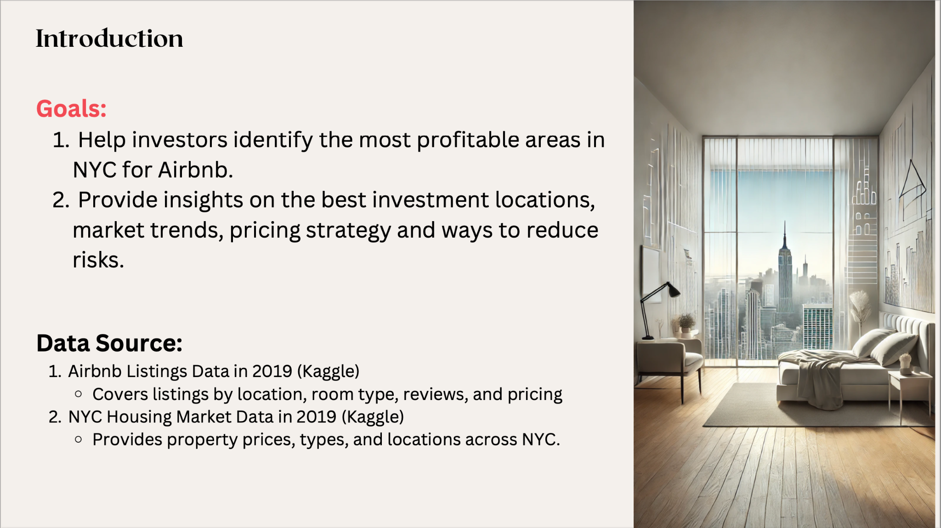As global travel recovers, the demand for short-term rentals like Airbnb is rising, especially in high-tourism cities like New York. Many property owners are capitalizing on this trend, but selecting the right locations and strategies is essential to maximize profitability and minimize risk.

This project develops an interactive dashboard to provide investors with insights into property selection, estimated returns, market trends and pricing strategy. Using Airbnb listings and NYC housing data, we identify high-demand neighborhoods, optimal property types, and rental approaches—whether whole units or shared spaces—tailored to market needs. The dashboard also assesses risks like market competition and fluctuating property values to guide investors toward stable, profitable opportunities.

New York City, with its high visitor volume and diverse market, serves as the ideal focus for this analysis. Our goal is to equip investors with actionable recommendations for maximizing returns in the Airbnb market.

**Modeling ROI**

# 

Our return on investment is calculated by:

**revenue / cost**

The cost of investment is the housing price, while the revenue is the amount that the investor is able to generate by converting their property into an Airbnb. The formula for calculating revenue is:

**required minimum stay * the number of reviews * the price for staying**

Since we do not have access to the occupancy rate of the Airbnbs, multiplying the minimum stay length required by the number of reviews received is the best approximate we can come up with given the limitations of our datasets.

**Map**

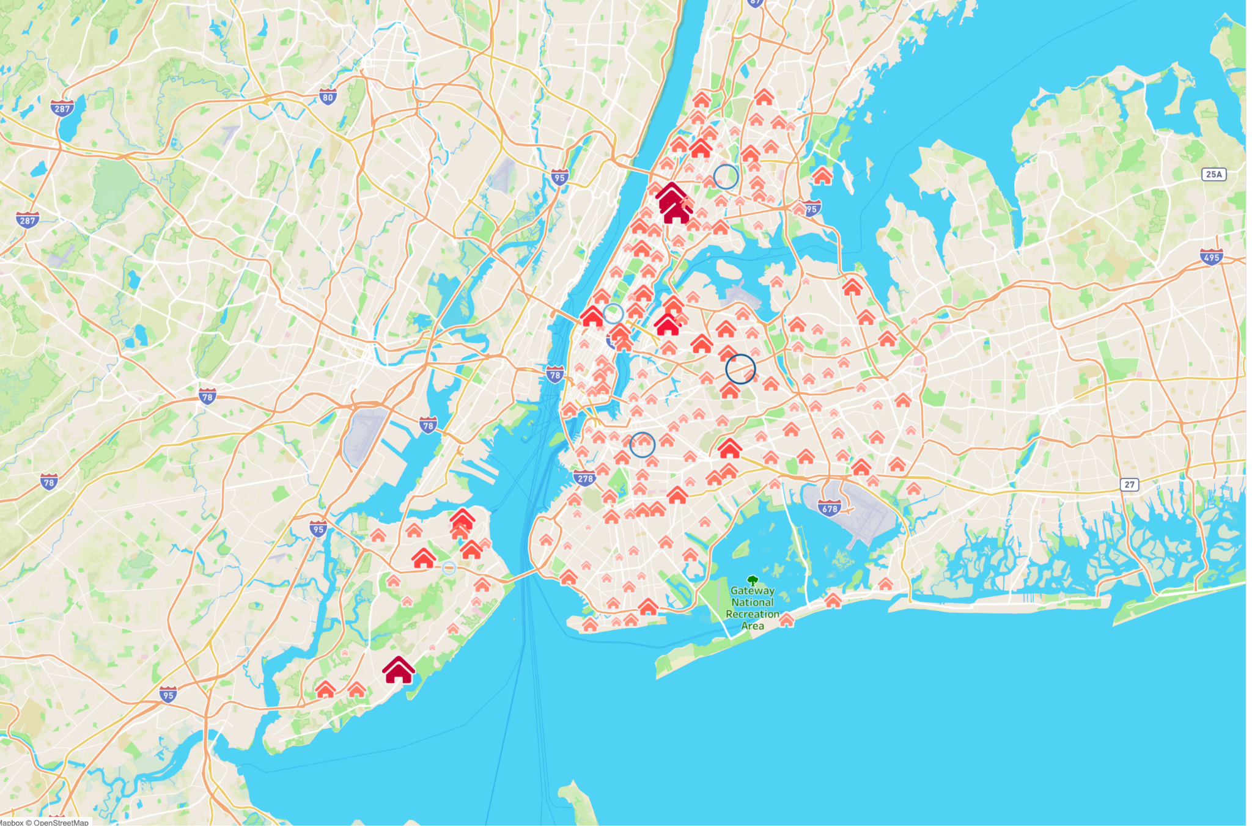

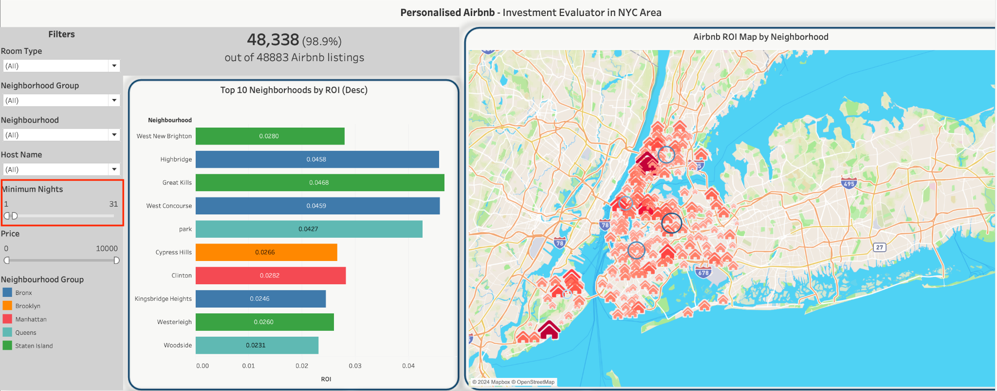

**Objective:**

This map aims to provide a data-driven view of the ROI for Airbnb investments across New York City neighborhoods, helping prospective investors identify the most promising areas.

**Methodology:**

ROI is calculated by dividing the projected revenue (based on the average nightly price, minimum stay requirements, and booking frequency from Airbnb listings) by the average property price in each neighborhood. All data used are taken from the year 2019. This metric highlights the expected return on investment for Airbnb properties in different areas.

**Results:**

The map shows that Staten Island and the Bronx offer the highest ROI, presenting them as strong potential investment areas. Manhattan, despite its fame and attractive location, has lower ROI due to high property prices and short-term rental market saturation.

**Investment Strategies:**

Situation：long-term rentals(stay of over a month)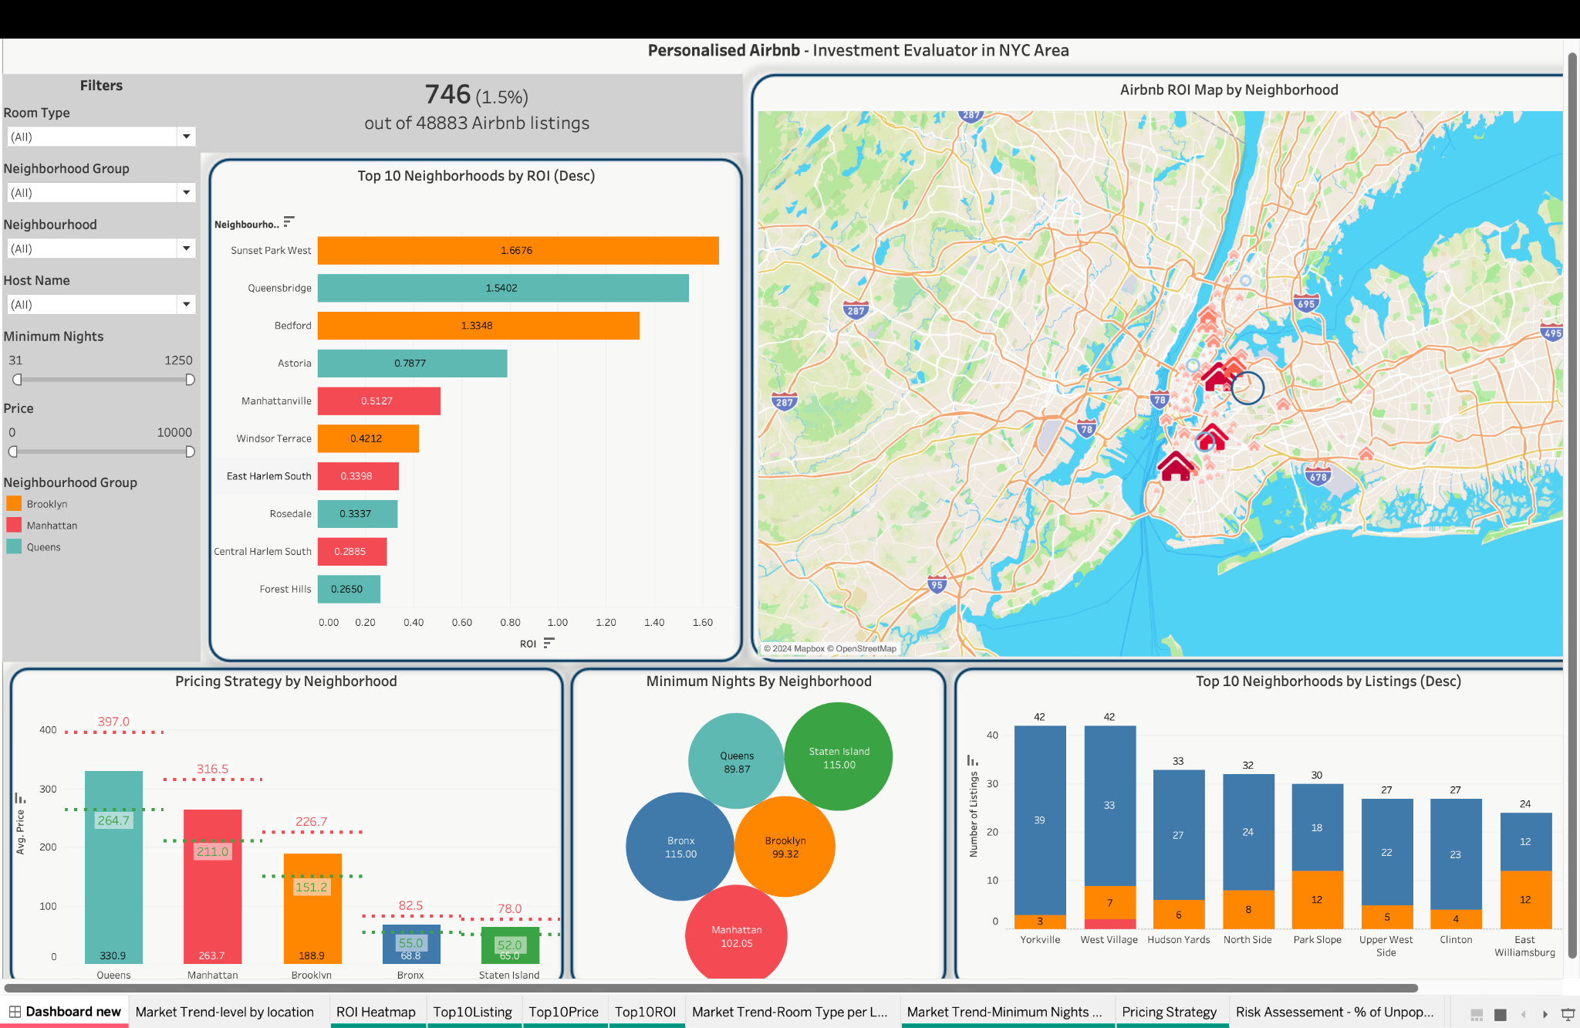

Situation: higher-end Airbnb properties(nightly price above $200)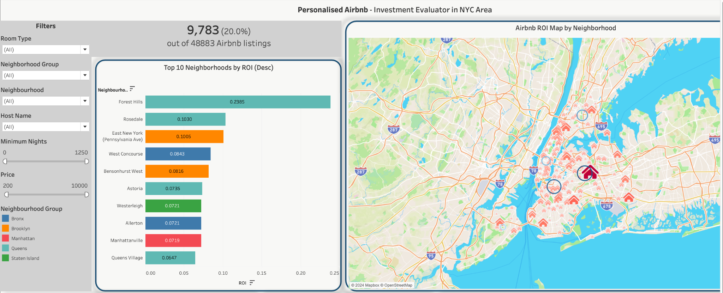

Situation: investing in private rooms rather than other room types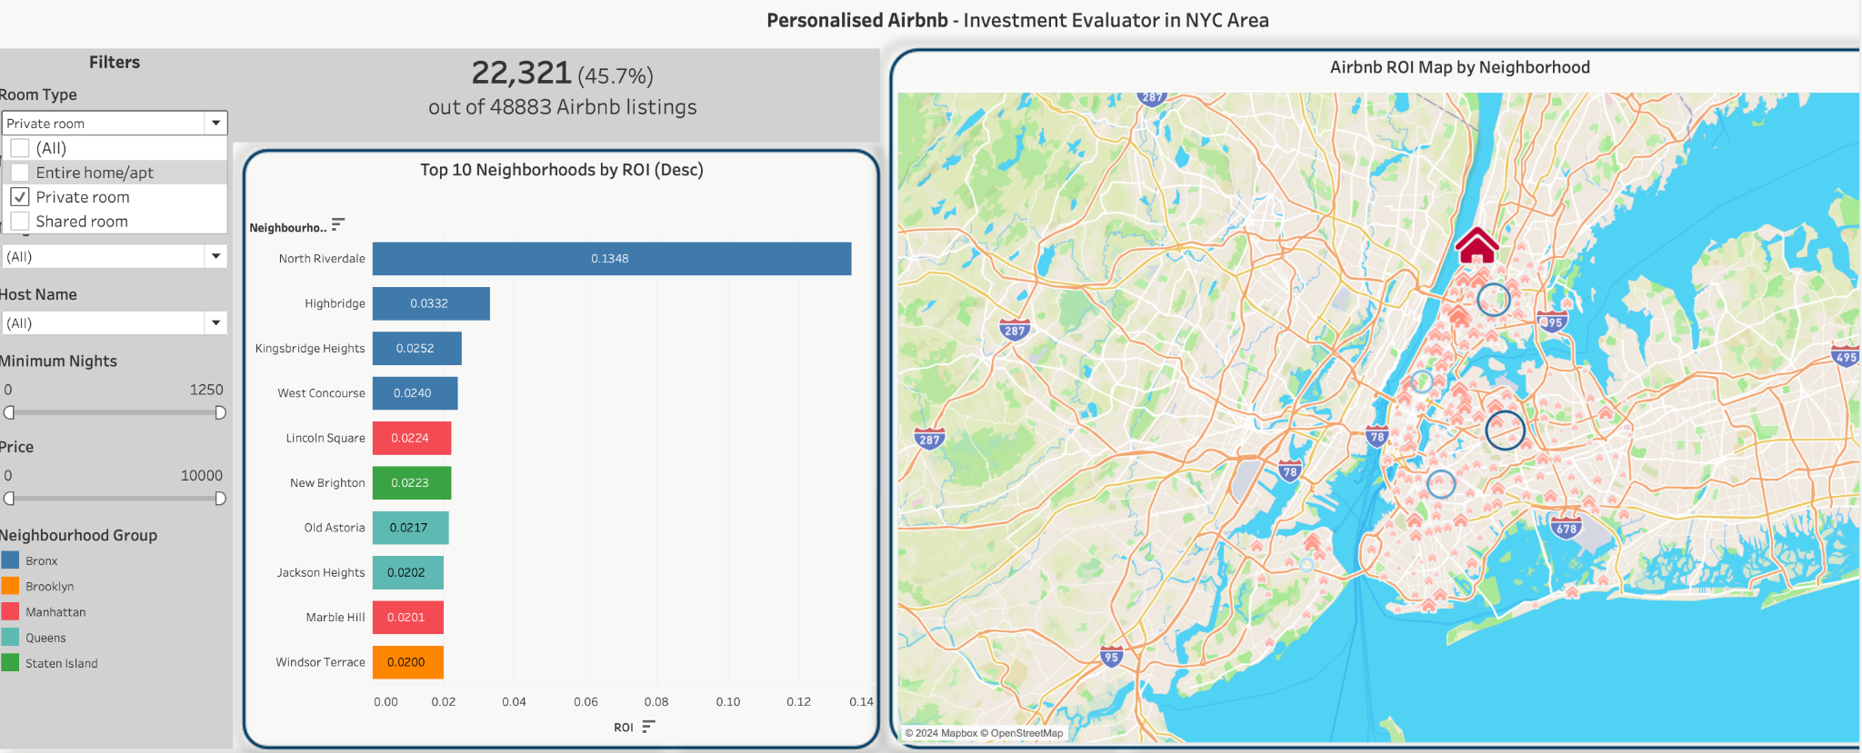

To boost ROI, investors can focus on long-term rentals or target higher-end properties. For instance, setting a minimum stay of 31 nights highlights neighborhoods with high ROI for long-term stays. Forest Hill shows the highest ROI for properties priced over $200 per night, while North Riverdale performs best for private room rentals.

**Conclusion:**

This analysis identifies Staten Island and the Bronx as top areas for Airbnb investment, while Manhattan’s high costs and saturation limit its ROI. Tailoring investments through filtering can help investors optimize their returns.

# 

# **Sorting: Top 10 Neighborhoods**

Through sorting top 10 neighborhoods by different indexes, investors can understand the current market situation and the pricing strategies of other sellers in the market. Then they will know where they should set their businesses.

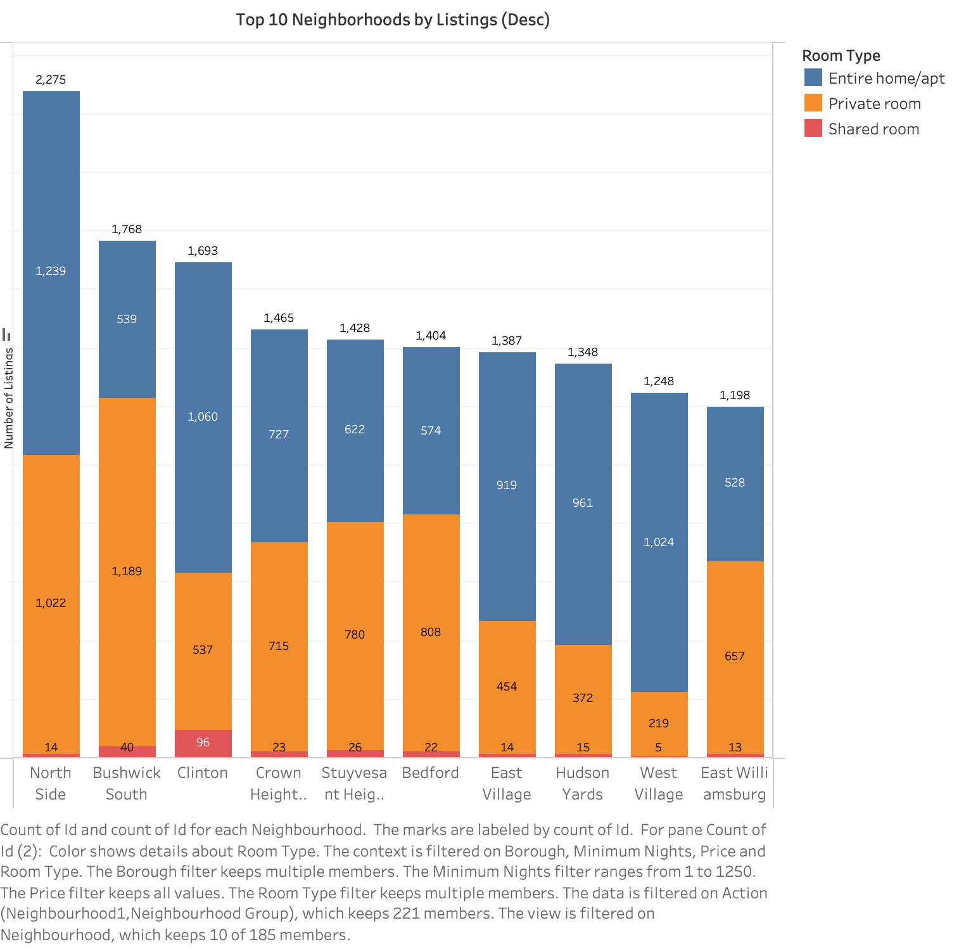

For the top 10 neighborhoods sorted by the number of listings, we found that North Side was the most dense neighborhood with 2275 Airbnb listings, and there exist different preferences for room types across neighborhoods.

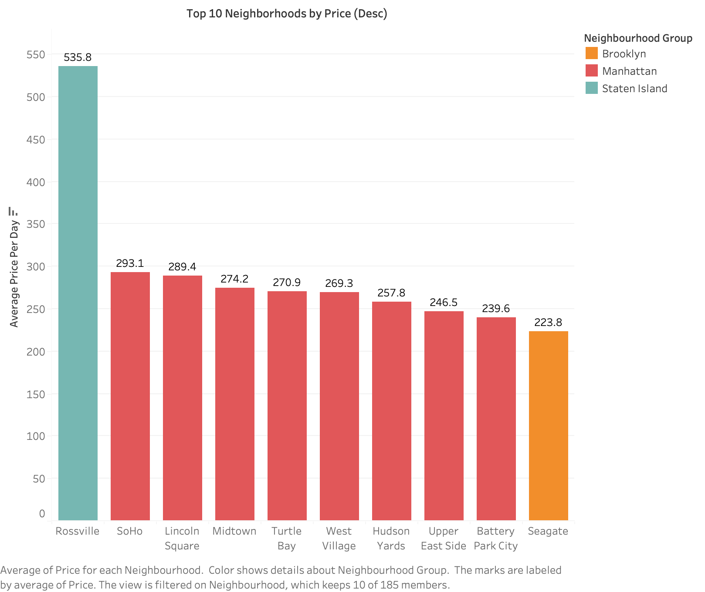

For the top 10 neighborhoods sorted by rental prices, we found that Rossville has the highest price of $535.8 per day, much higher than any other neighborhood. Among the five districts, Manhattan has much more “expensive neighborhoods” than other districts.

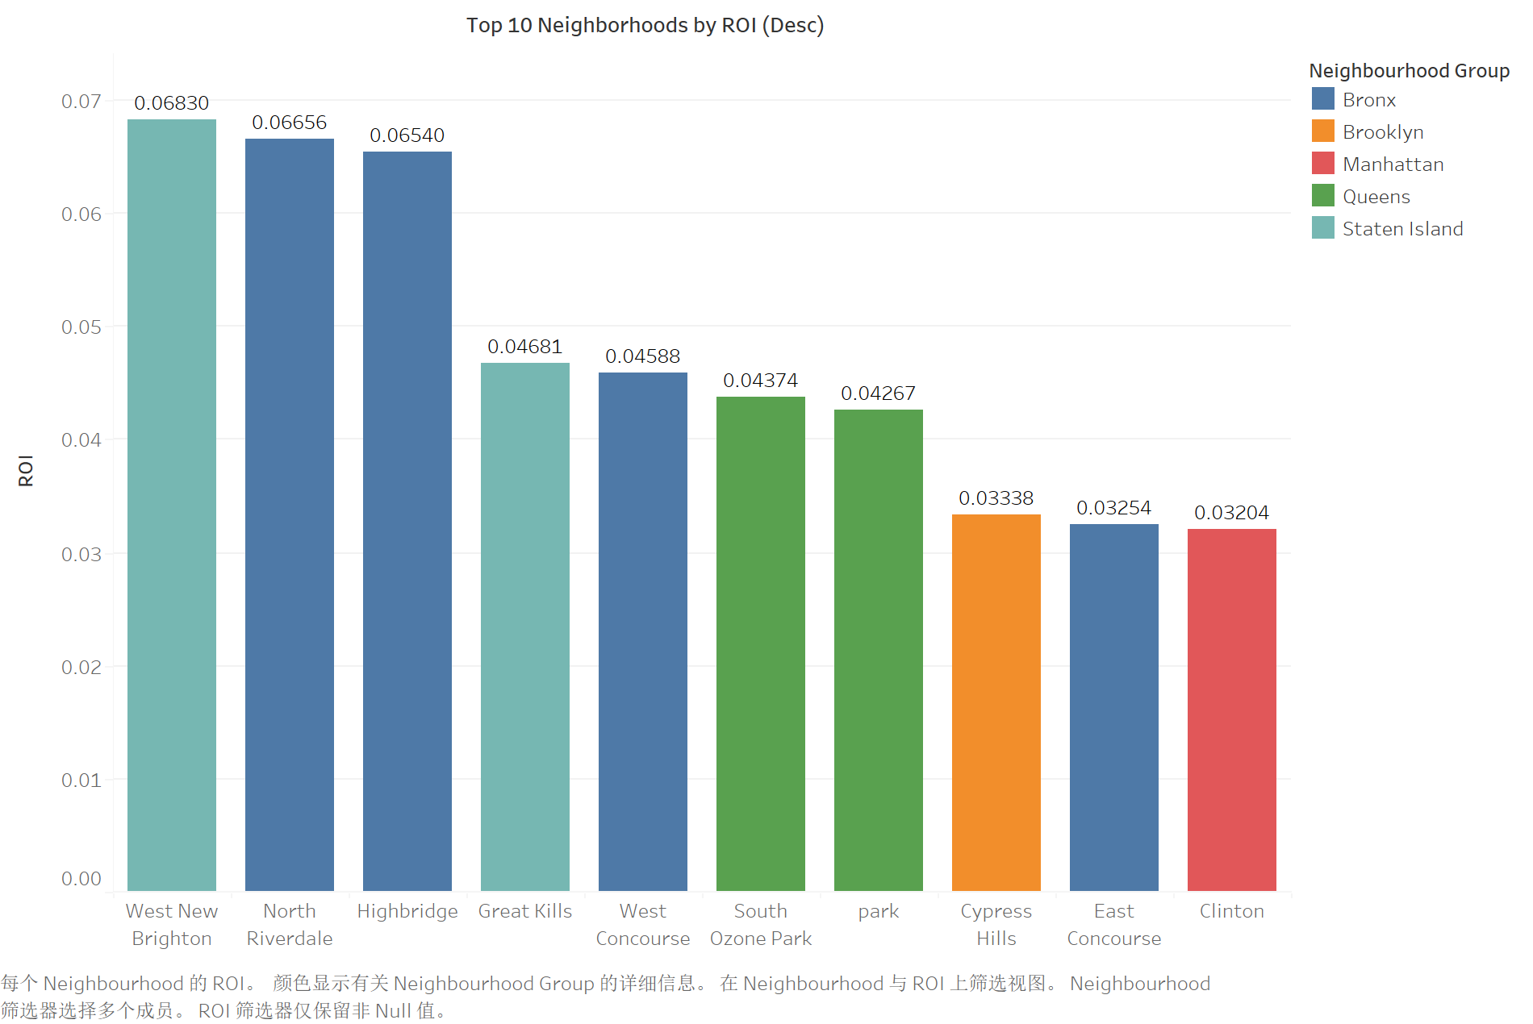

For the top 10 neighborhoods sorted by ROI, we found that West New Brighton has the highest ROI, which means it can be a profitable choice. Among the five districts, Staten Island and Bronx have more neighborhoods with higher ROI.

# 

# **Market Trends**

**Goal:**The goal of the visualization was to allow the the AIrbnb investor to get the following insights:

**Identify Minimum Stay Trends:** Highlight areas with higher or lower minimum night requirements (e.g., Coney Island with 4.47 nights, Breezy Point with 1 night).

**Competitive Insight: Help owners s** Show where lower minimum stays may attract more short-term guests, helping owners adjust policies to align with local competition.

**Geographical Insights:** Visualize trends across neighborhoods, aiding decisions on where to focus on long-term or short-term rentals.

**Neighborhood Preferences:** Reveals which areas cater to longer vs. shorter stays, informing listing descriptions and investment decisions.

**Visualisations used:**

**Minimum nights stayed in each location.**

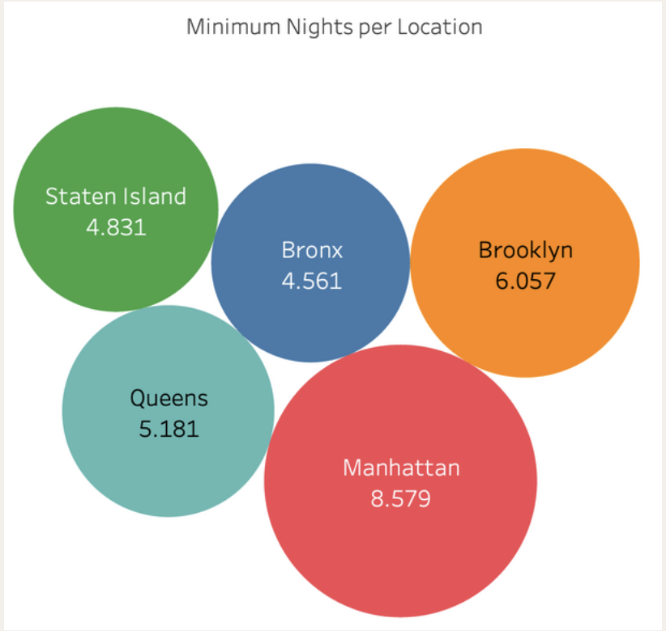

**Key Insights:**

* **High Minimum Nights**: Neighborhoods like Greenpoint (13.6 nights) and Long Island City (8.8 nights) cater to longer-term stays.
* **Low Minimum Nights:** Areas like Financial District (2.5 nights) and Jamaica Hills (1.7 nights) are more suited for short-term stay**s.**
* **Size of Squares:** Likely indicates price or minimum nights—larger squares suggest higher values, helping identify high-demand or high-price areas.
* **Room Type Colors:** DIfferent colours representing each room type are used tospot where certain types of listings dominate, e.g., Entire Homes in high-demand areas.

### **Strategic Takeaways for Airbnb investors**

* **Long-Term Focus:** For areas like Greenpoint, optimize for long-term guests.
* **Short-Term Focus: I**n areas like the Financial District, cater to short-term visitors.
* **Price Optimization:** Larger squares in high-demand neighborhoods indicate pricing potential for longer stays.

**Most popular room type in each location**

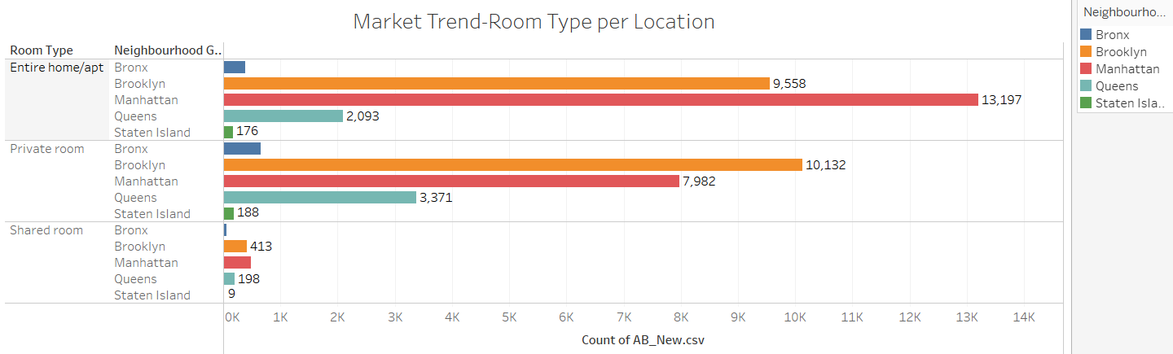

### **Key Insights:**

1. **Manhattan and Brooklyn Lead in Entire Homes**:
   * **Manhattan (13,199)** and **Brooklyn (9,559)** dominate **Entire Home/Apt** listings, making them prime markets for full-home rentals.
2. **Private Rooms Popular in Brooklyn and Manhattan**:
   * **Brooklyn (10,132)** and **Manhattan (7,982)** also have strong **Private Room** listings, appealing to budget-conscious travelers.
3. **Shared Rooms Are Rare**:
   * **Shared Rooms** are less common, especially in **Manhattan (480)** and **Brooklyn (413)**.
4. **Smaller Markets in Bronx and Staten Island**:
   * **Staten Island** and **Bronx** have far fewer listings across all room types, indicating smaller Airbnb markets.

### **Strategic Takeaways for Airbnb investors:**

* **Focus on Entire Homes** for high-demand markets like **Manhattan** and **Brooklyn**.
* **Private Rooms** are also highly competitive, offering budget-friendly options in the same boroughs**.**

**Active Listings**

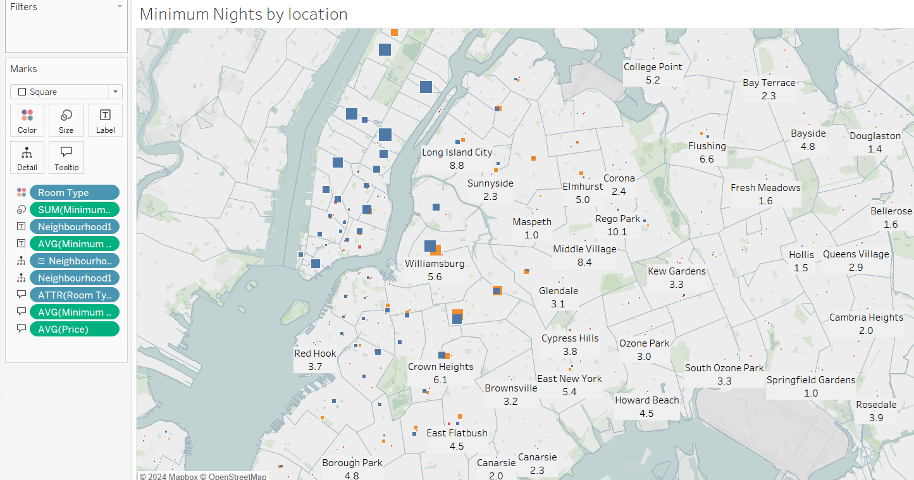

**Goal:**This map is an animation. The goal of this visualization is to highlight which neighborhood groups are the most active (as per last month's data).

### **Key Insights:**

1. **High Minimum Nights**:
   * Larger squares, especially in **Washington Heights South** and **University Heights**, indicate neighborhoods with high minimum night requirements.
   * These areas might target long-term stays, ideal for guests looking for extended accommodations.
2. **Low Minimum Nights**:
   * Smaller squares are clustered in areas like **Jackson Heights** and **Corona**, suggesting shorter minimum stay requirements that cater to tourists or short-term visitors.
3. **Neighborhood Clustering**:
   * **East Harlem South** and **Astoria** have a balanced mix of high and low minimum nights, offering options for both long-term and short-term guests.
4. **Geographic Distribution**:
   * Coastal areas like **Turtle Bay** and **Queensbridge** show varying minimum nights, which might be attractive to travelers looking for flexible stays near waterfront areas.

### **Strategic Takeaways for Airbnb investors :**

* **Long-Term Focus**: For listings in **high minimum night** areas (e.g., **Washington Heights South**), focus on marketing to longer-term guests.
* **Short-Term Focus**: In neighborhoods with **low minimum nights** (e.g., **Jackson Heights**), target tourists or short-stay visitors.

## 

## **Pricing Strategy**

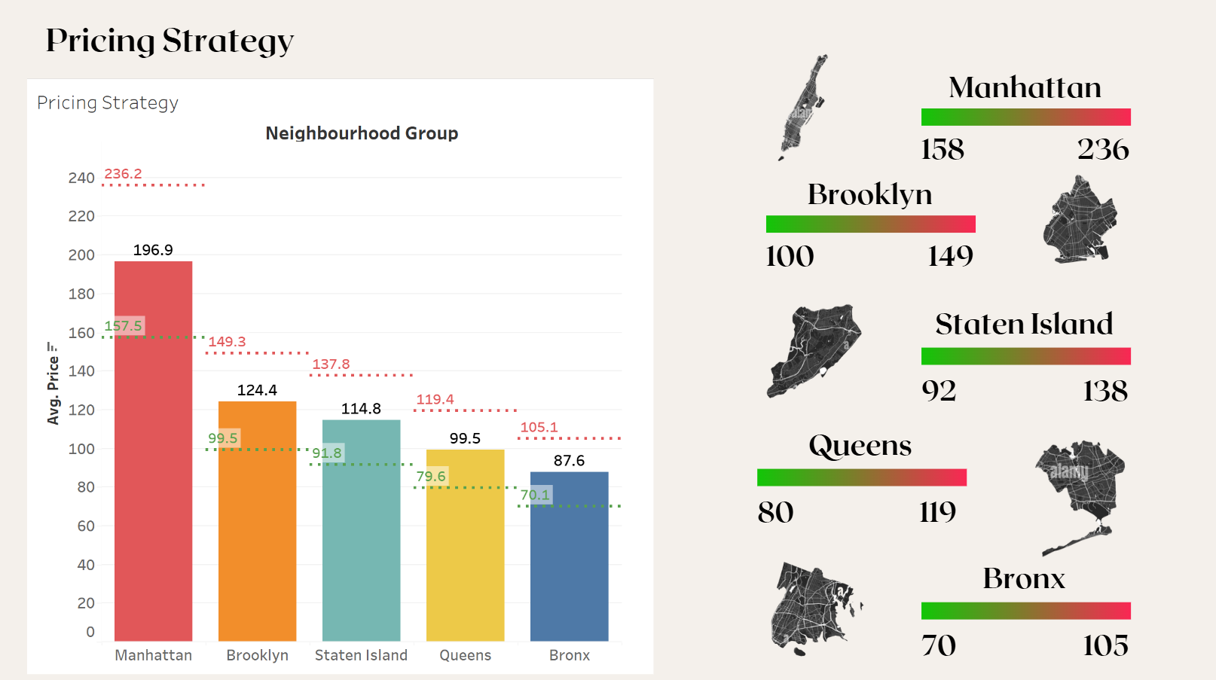In developing a competitive pricing strategy, average prices for each borough is calculated as a baseline reference. It is recommended that the pricing for your listings should fall within the range of 80% to 120% of the average price in the respective borough. This approach allows for flexibility while ensuring alignment with local market dynamics.

### **Price Range Guidelines:**

* **80% of the baseline** is considered the lower threshold for competitive pricing, indicated by the green line in the chart.
* **120% of the baseline** serves as the upper threshold, represented by the red line in the chart.

### **Strategic Takeaway:**

This range is designed to provide a balanced strategy that maintains market competitiveness while maximizing potential profitability. Below are the specific average price ranges for each borough:

* **Manhattan**: Recommended pricing between **$158** and **$236**.
* **Brooklyn**: Recommended pricing between **$100** and **$149**.
* **Staten Island**: Recommended pricing between **$92** and **$138**.
* **Queens**: Recommended pricing between **$80** and **$119**.
* **Bronx**: Recommended pricing between **$70** and **$105**.

This pricing strategy enables a targeted approach to align your offerings with consumer expectations across various locations, ensuring both affordability and profitability within the local market contexts.

# **Risk assessment**

## **1. Percentage of unpopular listings**

## 

One way we are approaching risk assessment is to come up with an approximate for the vacancy rates of all the listings, since this information is not readily available in the dataset. We decided to use the number of reviews each property received over 2019 as a measure of how popular each listing is.

An unpopular listing is defined by any listing that has numbers of reviews that are lower than the median numbers of reviews. After calculation, we found that the median numbers of reviews in this dataset is 5. Therefore, any listings with less than 5 reviews would be considered unpopular.

The percentage of unpopular listings is thus calculated by:

**the number of unpopular listings / the total number of listings**

To provide us with more insights, we categorized the results by neighborhoods to find out the exact percentages of unpopular listings in each neighborhood. The results show that Manhattan has the highest unpopular listings rate and Staten islands have the lowest.

This would only roughly indicate the popularity of Airbnb in each of the 5 neighborhoods in NYC, as the number of reviews received is only a rough approximation of how many times each listing gets book. However, with a more complete dataset, our idea to calculate the vacancy rate can provide investors with meaningful insights.

## **2. Fluctuating Property Values in 2024**

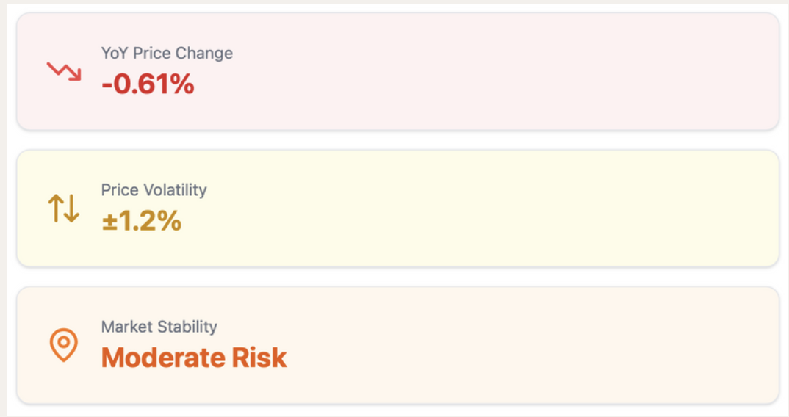

The NYC real estate market is experiencing varied trends across boroughs, which affect the potential for Airbnb investments. According to the **New York Housing Market Trends & Forecast** article, Manhattan and Brooklyn are seeing property value declines of 0.61% year-over-year, increasing risks for investors in these areas. Volatility remains high, with property prices fluctuating by ±1.2%. As a result, these boroughs require more careful pricing strategies and risk management.

In contrast, Queens and Staten Island are showing stable to slight growth, making them more suitable for long-term investments. With their relatively safer market conditions, these areas present opportunities to secure stable returns through consistent Airbnb demand.

Given the market’s moderate overall risk, investors need to carefully monitor borough-specific price trends to make timely decisions. Dynamic pricing strategies will help optimize revenue during periods of high volatility. Prioritizing investments in growing areas like Queens and Staten Island can provide a better balance of risk and return in the current economic environment.

# **Reference**

*New York Housing Market Trends & Forecast 2024*. Innago. (2024, July 3). https://innago.com/new-york-housing-market-trends-forecast/#:~:text=Median%20Home%20Price,housing%20prices%20in%20the%20state.

We used ChatGPT for some prompts to give us ideas on how we can analyse the dataset to provide deeper insights for the purpose of our project. The following some of the prompts that we used:

Airbnb Price Prediction and Visuals - convert this into a business problem.

You are an airbnb owner. Your job is to find the most profitable locations in Vancouver.

You will need a dashboard for the most important factors everyweek.

What factors can you include in the dashboard? Design a visualization project

For our complete chat history with all the prompts we used, please refer to this link:

https://chatgpt.com/c/6716c671-93f8-800a-b967-ec57531c4982